CS 145
Adalia Williams
Assignment: Final Project
Create-an-Outfit Website
Version <1.0>

Table Of Contents
Favicon Image & Developer Introduction…………………………………………………….….3
Time Log………………………………………………………………………………………………………….4
Introduction 6
Purpose 6
Definitions, acronyms, and abbreviations 6
Overall Description 6
Story Board 7
Specific reqements 9

Favicon:
The thought process for this favicon is meant to show the purpose of the website. This is meant to show “arrows” to quickly rotate and see all clothing options in the user’s closet in a quick rotation.
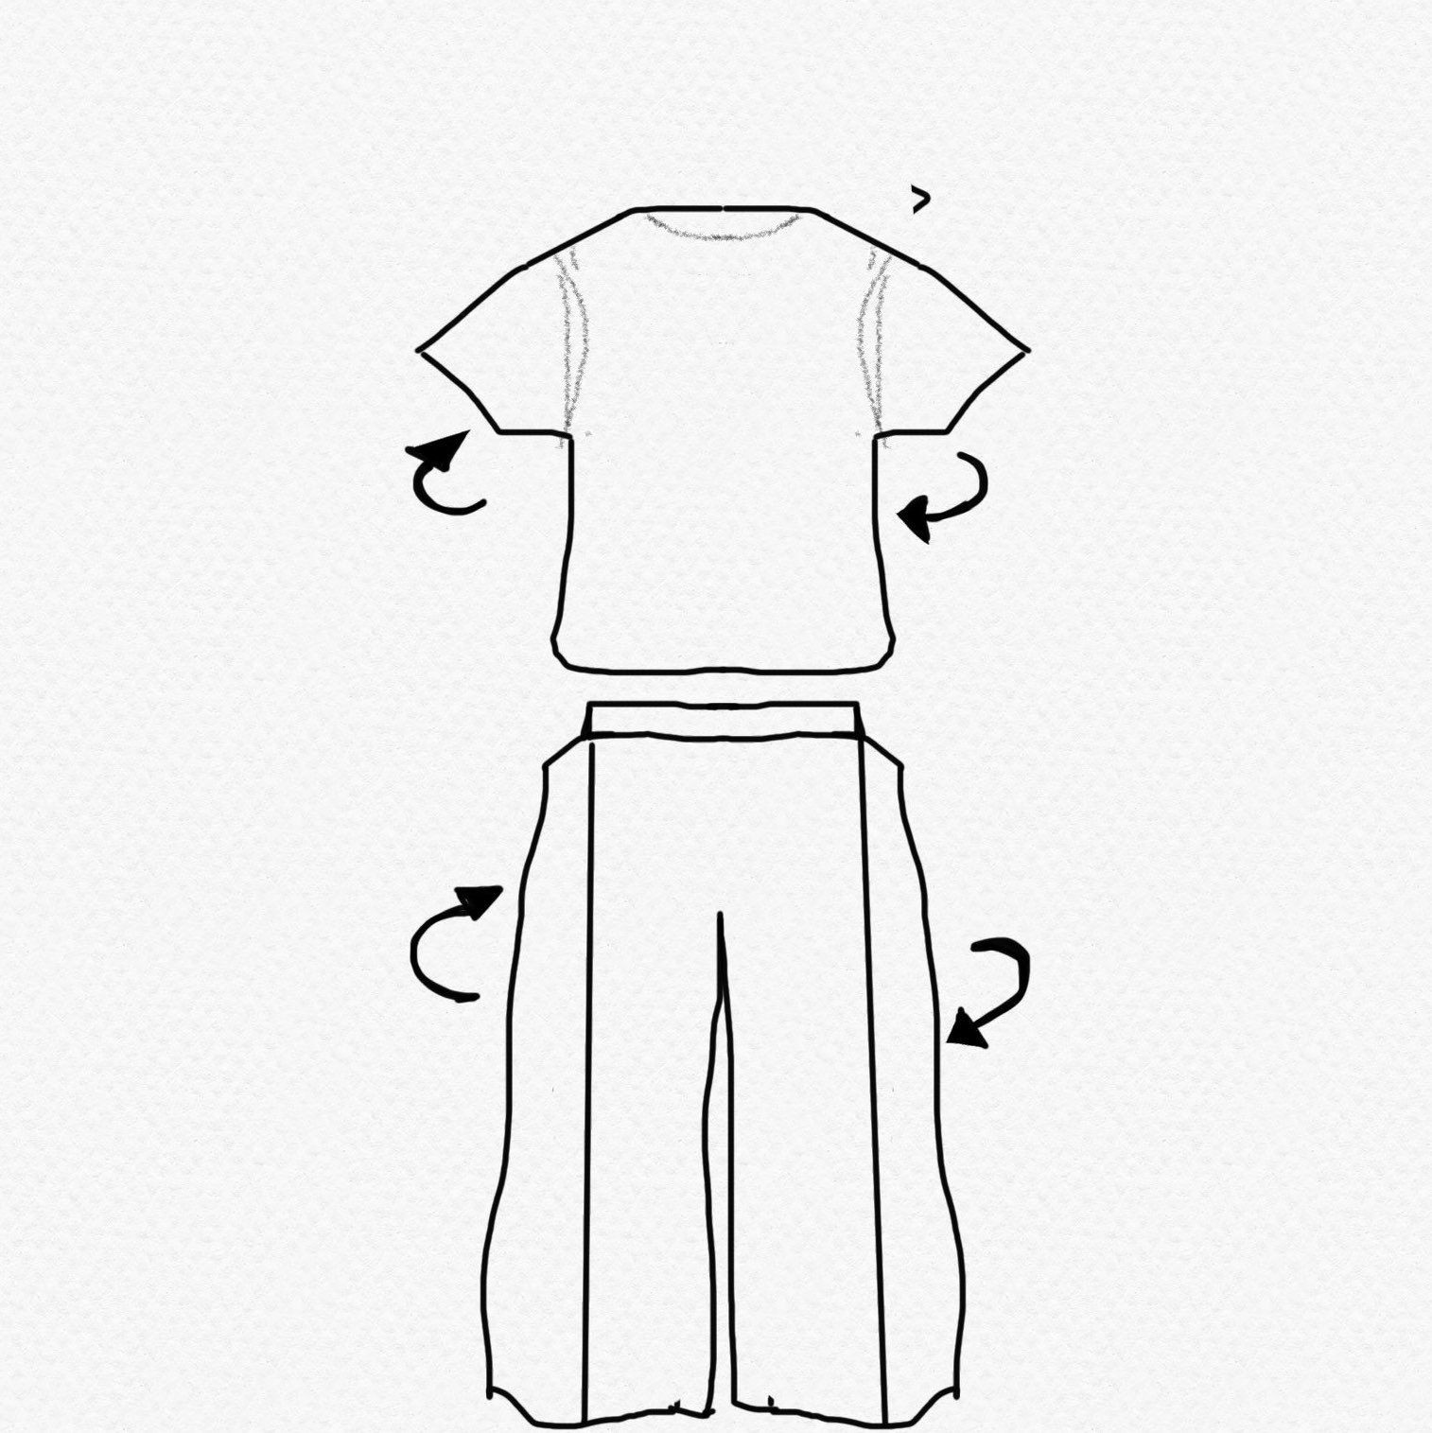

Developer:
This website was developed by Adalia Williams, a student at University of Vermont, studying Computer Science.
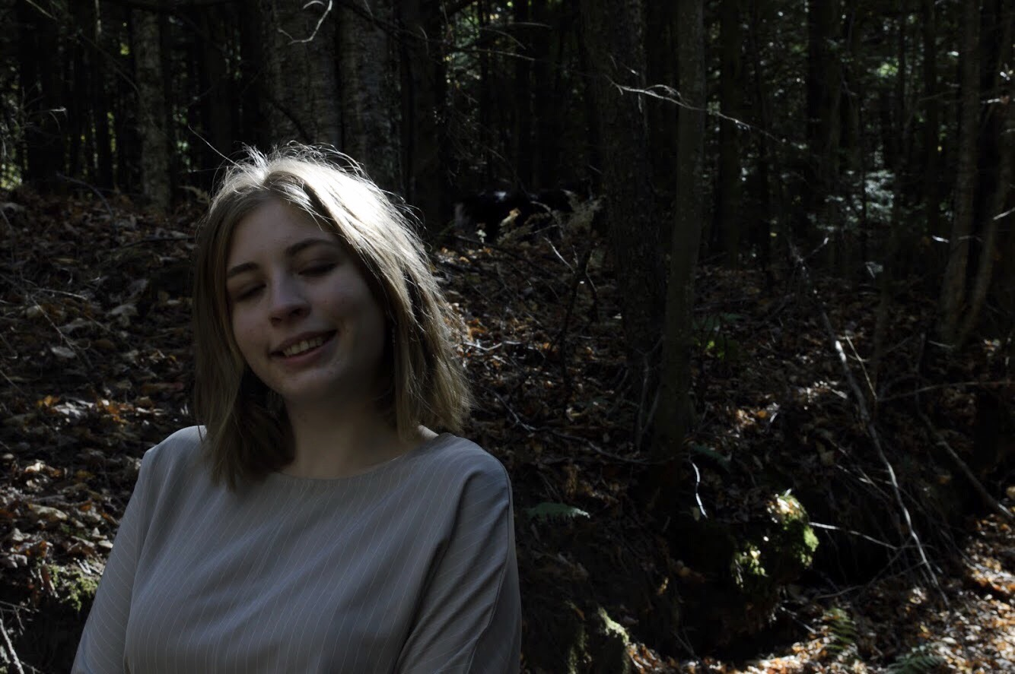
]

Time Log
Estimated time to complete assignment => |  |  | 20 Hours
Date | Time Spent  (in hours) | Description | Author
06/28 | 6.0 | General Discussion of the Website, JavaScript inclusions are contemplated and put into effect. A general layout of the website was created and FTPed. | Adalia Williams
06/29 | 6.0 | Started JavaScript Codes, added form, begun CSS. | Adalia Williams
06/30 | 8.0 | Completed JavaScript for form. Created 5 Slideshows with JavaScript. Completed CSS for the website. | Adalia Williams
07/01 | 2.0 | Completed Project Specification Document | Adalia Williams
 | 22 | <=Total Time Spent

Introduction

Purpose
The purpose of this document is to describe the requirement specification for the web site “Build an Outfit”.
The intended audience for this document is Robert Erikson.

First it is the contract between you and the client. Second it is for the developer of the site. Two primary goals are:
- Client gets a very good understanding of what you will be delivering.
- Developer has a very good understanding of what they are going to create.

Definitions, acronyms, and abbreviations

Information and Images are from:
https://www.urbanoutfitters.com
**note: my-choices.html was saved as index.php

Overview
This website contains many photographs, meant to be a showcase of the user’s closet. The user would also be able to use a slideshow feature to “choose” which item of clothing they hope to wear for that day. The website also contains a form for the user to submit new items of clothing into the website.

Overall Description
This website was created to help the user see their whole closet at the touch of their hands. This website is created to be easily modified and easy to navigate. The main purpose of the website is to help the user create an outfit to wear for the day. This outfit will be saved with the date it was created and saved to an archive for easy access to use an outfit again. An outfit can be created by filling out a form or from starting with one item that will be automatically fill into the form. The user has full control on their outfit.

Story Board
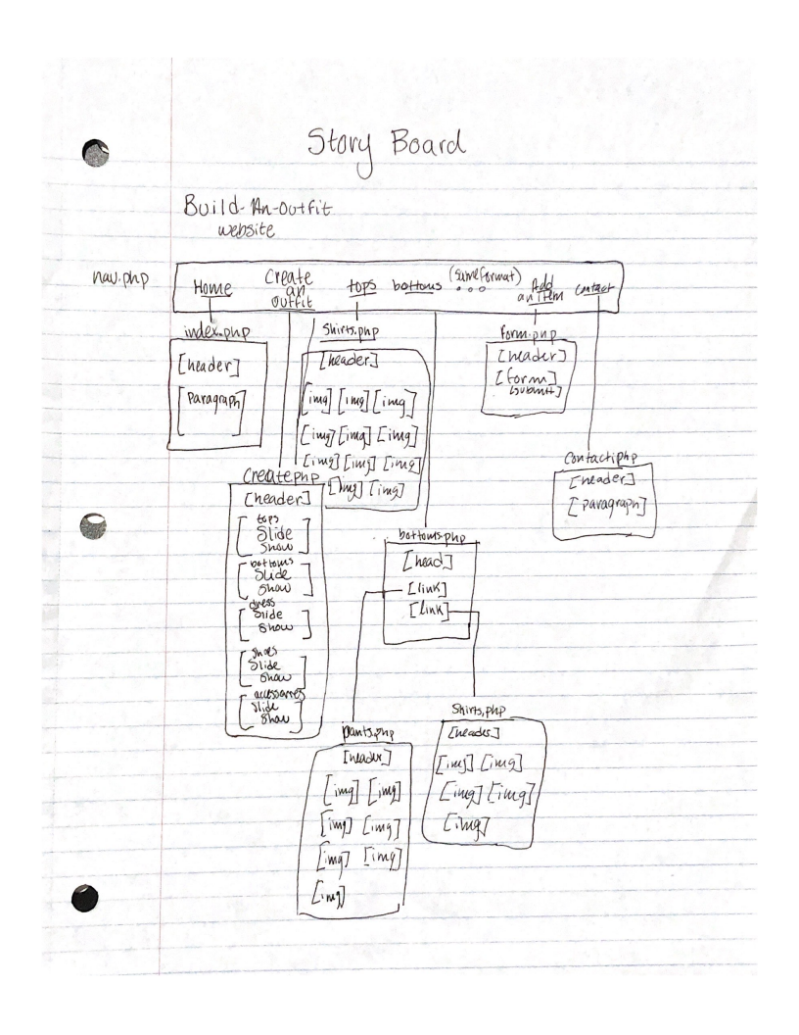

Moving Forward
In further development I hope to link a database with this website so that it can be modified easily by the user and clothing items can be added and removed as the user sees fit.

I hope to also add a weather feature to the index page so that the user knows that the weather is going to be so they can dress appropriately.

